Suggestions for activities for Particle Model

Instructional Goals

- Describing Matter
- Recognize that matter exists in three common states – solids, liquids and gases. Each is described by a set of distinguishing properties.
- Visualize matter as composed of tiny BB-like particles (molecules).
- Use a particle model of matter to account for the behavior of solids, liquids and gases.
- Recognize density as a unique property of matter that can be used to identify a substance.
- Use a particle model of matter to account for differences in the observed properties of a substance (e.g. density, melting point, boiling point and solubility).

Activity 1 - Describing Matter

Apparatus:
Solid substances having very different properties (one per group)
Some possible substances include:
- Paper clip
- Moth ball
- Sugar cube
- Eraser
- Sheet of colored construction paper
- Piece of Plexiglas
- Aluminum foil sheet
- Piece of plastic (from a plastic container)
- Rock salt
- Styrofoam peanuts
- Cotton ball
At a location accessible to students (several of each that groups may choose to use):
- Hand lenses
- Balances
- Metric rulers
- Graduated cylinders
- Conductivity testers
- Magnets
- Small beakers
- Water
- Scissors

1.1 Student Activity: Describing Matter

- Examine the sample of matter your group has been given. Try to describe your matter as completely as possible. Your teacher will point out some measuring tools and other items that you may want to use. Use complete sentences to record your observation and measurements below. Be prepared to post a list of one – or two-word characteristics that best describe your matter on a whiteboard so it can be shared with other groups.

* * After all of the samples have been discussed in a whiteboard session, examine them for similarities and differences. Try to answer the following questions.

- Do the lists on the whiteboards give your group ideas for additional characteristics that you could add on your list? If so what?

- Which of the characteristics on your list describe the object your group observed, and which describe the material of which object is made?

- Did you list any characteristics that would change if you had a different amount of matter in your sample? If so which ones?

- Are any of your observations quantitative (involve making a measurement)? What is the advantage of making quantitative observations?

- Did different groups use different words to describe the same characteristics? If so, what? Then circle or add the term that a scientists use to describe that characteristic?

- What do we mean by a “property” of matter?

Activity 2 - Classifying Matter

Apparatus:
Preparation Note: Make up identical sets of items for the groups, using whatever is interesting and what you have access to. Ensure that sets have a good range of materials and include solids, liquids, and gases. Be sure to include items that are difficult to classify as solid, liquid, or gas (such as the flour, clay, and shaving cream).

Copies of Student Classifying Matter worksheet
For each group, six or seven of the following items, each contained in a Ziploc® bag:
· Metal bolt or washer
· Rocks
· Sugar or Kool-Aid
· Modeling clay or other similar substance
· Flour
· Balloon or rubber bands
· Colored shampoo
· Vinegar
· Glue
· Rubbing alcohol
· Cornstarch and water mixture
· Shaving cream
· Air
· Helium

1.2 Student Activity: Classifying Matter

Materials:
A set of Ziploc bags containing samples of matter.

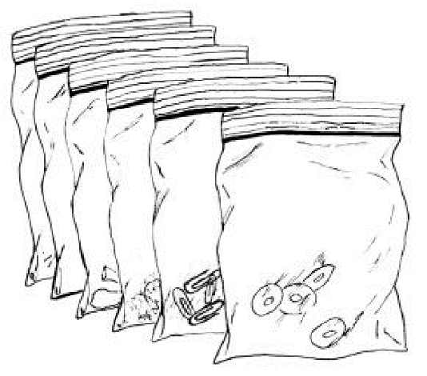

Procedure:

- On your own, look at the samples of matter your group has been given. How are they similar? How are they different? Brainstorm ways that you might order or group the samples based on their observable characteristics. Describe the characteristic you group will use to organize the bags below.
Similarities:

Differences:

Organizational scheme:

- In your group, share your ideas for organizing the samples. Pick one method of organizing to show to the other groups. Try to think of a way that the other groups may not have thought of. Display your actual samples in this way on your table. Other groups will visit your display and try to figure out the reason behind your organizational scheme. List the bags in order based on your organization scheme below. Wait for directions from your teacher before proceeding to question 3.

- Visit other groups’ displays and try to figure out the reasons for them. List your ideas in the table below. Then record the actual organization scheme used by the group when it is revealed in the whole group discussion.

Group Number | Method of Organization
 | Prediction of your group | Actual Organization scheme
1
2
3
4
5
6
7
8
9
10

- Discuss in your group why we might want to organize matter in a particular way. Record notes from your discussion below. Consider and discuss
  - Ways in which matter is organized in everyday life, such as in a grocery store,
the local hardware store, their clothes closet, etc.
- Why chemists might need to organize chemicals in their storeroom in a particular way
- Whether it is always easy to classify items (for example, there are items at the grocery store that are always hard to locate because they don’t logically fit into a single category -- such as flaked coconut).

Notes from our group’s discussion…

Additional ideas from the whole group discussion ….
- All groups will now classify your samples of matter in the same way (solids, liquids, and gases) and then we’ll see if we agree.. Complete the table below. Have one person in you group draw the table on whiteboard with your group’s consensus of the classification. Be prepared to share your table with other groups and be able to justify why you put each sample in the category.

Solid | Liquid | Gas

- Research properties of solids, liquid and gases and list these properties in the table below.

Properties of States of Matter
Solid | Liquid | Gas

- Make a final list of properties of the states of matter that includes the consensus of your class below.

Properties of States of Matter
Solid | Liquid | Gas

- Make a list of questions in your group that you would like the class to investigate further and find answers to below.

Activity 3 - Evidence for Tiny Particles
Apparatus:
For each group of students:
- Magnifying glass or a hand-held microscope
- Newspaper or magazine picture
- large round balloon
- almond or vanilla extract
- beaker or clear container of water
- sugar (individual restaurant packs are recommended)
- stirring rod

For teacher demonstration:
- Volumetric flask
- Sugar
- Digital balance
- Meter stick or metric tape measure
- Funnel for adding sugar
- Beaker for weighing sugar

1.3 Student Activity: Evidence for Tiny particles

Materials:
· Newspaper or magazine picture
· Large round balloon
· Almond or vanilla extract
· Beaker or clear container of water
· Sugar (individual restaurant packs are recommended)
· Stirring rod
· Magnifying glass or a hand-held microscope

PART 1:
- Look at a color newspaper or magazine picture with your naked eye. Then observe it again through a very strong magnifying glass or a hand-held microscope. Sketch and describe what you see.

PART 2:
1. Place several drops of vanilla or almond extract into a clean balloon. Be very careful not to get any of the extract on the outside of the balloon.

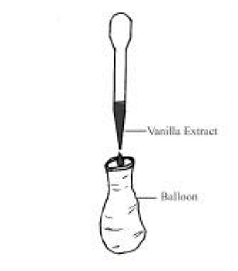

2. Carefully inflate the balloon and tie it. Can you smell the extract on the outside of the balloon? What are your explanations for what you notice? What evidence does this demonstration provide that matter is made of tiny particles? Discuss your ideas with other members of your small group before writing down what you think.

PART 3 Teacher Demo:

- Sugar into a beaker of water and stir. Record your observations.

- How does this provide evidence that matter is made of tiny particles? Discuss ideas in your group.
- Record some quantitative observations in the table below as your teacher mixes sugar and water together.

Substance | Volume (ml) | Mass (g)
Sugar
Water
Sugar + water mixed together

Questions:

- How is the picture in the newspaper like a sample of matter that we can observe and the particles that make them up?

- Draw a particle representation to show how the extract particles escape from the balloon in part 2.

- Draw a particle representation to show what may be happening to the sugar as it disappears in the water in part 3.

